**Applications of Op Amps**

**Purpose**

The purpose of this laboratory activity is to investigate various applications of op amps, specifically amplification, integration/differentiation, and addition/subtraction. Students will set up feedback networks with op amps and investigate the effects on the input signals at different frequencies.

**Experimental Apparatus**

## ADDITIONAL EQUIPMENT NEEDED

* function generator
* oscilloscope
* BNC cables, BNC connectors, banana cables etc.
* Digital multimeter

EQUIPMENT PROVIDED

* 4 capacitors (one 10pF, one 10nF, and two 1µF)
* Various resistors and wires
* 2 op-amps (the black chips with 8 pins each)
* 1 breadboard
* Two voltage or BNC sensors

**Theory**

What is an op amp? "op-amp" stands for **Operational amplifier**. Essentially, it is a cheap integrated circuit that can be used as a building block of electronics. It is an amplifier with a large open loop gain. It has an inverting input and a non-inverting input, and a single output. The relationship between the input and the output depends upon the feedback network that connects them.

An op amp performs operations on an input signal. Some of the possible operations include amplification, buffering, integration, differentiation, addition, and subtraction. When used in an open loop, the op amp has poor stability and very high gain (infinite for an ideal op amp). In a closed loop, the feedback adds stability and reduces the gain of the amplifier.

Basic rules of analyzing op-amp based circuits (as shown in Figure 1):

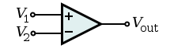

**Figure 1: An op amp with – (inverting) and + (non-inverting) inputs shown**

Rule 1: $V_{1}=V_{2}$

* The op amp changes its output to lower the voltage difference between its inputs to zero

Rule 2: $I_{1}=I_{2}=0$

* The inputs draw no current and are essentially connected to an open circuit

To analyze an op-amp circuit, the basic process is as follows: draw two circuits (one for each input) as if the op-amp is removed. Using standard circuit analysis and the above rules, solve for $V_{out}$ in terms of $V_{in}$.

**Before beginning the lab**, you should familiarize yourself with the workings of an op-amp. While researching it, consider the following question: If you cannot get power from nothing, where does the extra power in an amplified signal come from?

**Inverting Amplifier**

In Figure 2, the output of the inverting amplifier is equal to $-\frac{R_{f}}{R_{in}}$ times the input signal (why?). It is called an inverting amplifier because of the negative sign. The gain can be adjusted by changing the values of $R_{f}$ and $R_{in}$.

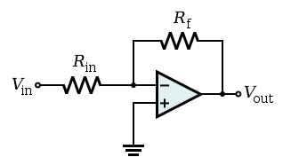

**Figure 2: An inverting amplifier circuit**

**Non-Inverting Amplifier**

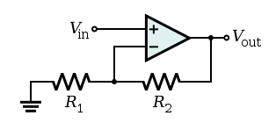

**Figure 3: A non-inverting amplifier circuit**

The output of the configuration in Figure 3 is equal to $\left(1+\frac{R_{2}}{R_{1}}\right)$ times the input signal (why?). It is called a non-inverting amplifier because the output retains the sign of the input. As before, the gain can be adjusted by changing the resistor values, but unlike before, it cannot be less than 1.

**Inverting Differentiator**

The output of the configuration in Figure 4 is equal to $–RC$ times the **derivative** of the input signal (why?). Note that this circuit is somewhat idealized. In reality, there will be some small resistance $R_{in}$ in series with the Capacitor, and the differentiator will only work at frequencies below $ω_{C}=\frac{1}{R_{in}C}$

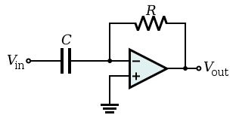

**Figure 4: An ideal inverting differentiator circuit**

**Inverting Integrator**

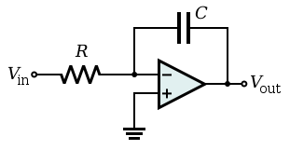

**Figure 5: An ideal inverting integrator circuit**

The output of the configuration in Figure 5 is equal to $-\frac{1}{RC}$ times the integral of the input signal (why?). Again, this circuit is somewhat idealized. In practice, the behavior of the device can be improved by adding a resistor $R_{f}$ in parallel with the capacitor. This does not come without a tradeoff, however, as it prevents the circuit from integrating at all frequencies. In practice, with the resistor in place, the integrator will work at frequencies above $ω_{C}=\frac{1}{R_{f}C}$

**Procedure**

The layout of the breadboard is shown in figure 6 below.

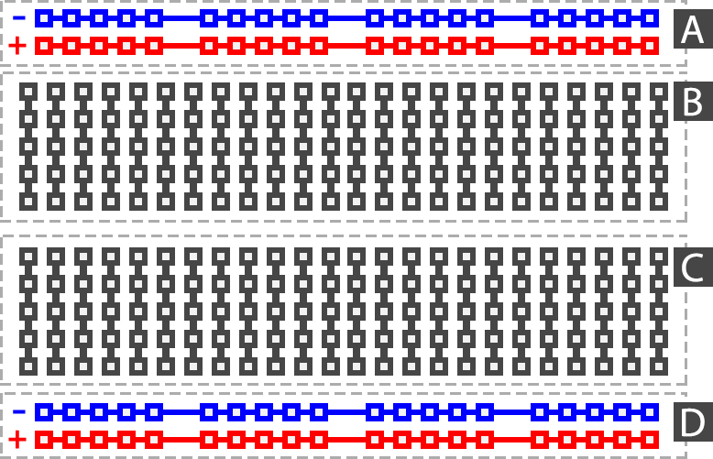

**Figure 6: The wiring layout of a standard electronics breadboard.**

Before getting started, make sure you can set up a signal on the function generator and observe it properly on the oscilloscope. You should also look through the data sheet provided on the op-amp so that you understand the pin-out and the required inputs. Furthermore, remind yourself how to determine the values of arbitrary resistors.

**Exercise 1: Inverting and Non-Inverting Amplifiers**

Construct inverting and non-inverting amplifiers. For each type of amplifier, do the following:

Set up the circuit. Start with resistance values of 10 and 100 kΩ. Try a sine wave on the function generator. What frequency and amplitude should you use? Does it make a difference? Sketch the input and output together on the same graph, or save the data directly from the oscilloscope. Try varying the resistor values as well as the frequency of the signal. Plot the output amplitude as a function of the input amplitude (choose as many input amplitudes as you see fit) for each set of resistances and compare to the theoretical gain.

Derive the theoretical gain for each type of amplifier. Why can you treat the op amp like it has been removed when analyzing the circuit?

Hint: If you are having trouble getting the proper signal, refer to the data sheet for the op-amps and also read through the theory section of the manual again.

**Exercise 2: Inverting Differentiator and Inverting Integrator**

For each type of circuit (inverting differentiator, inverting integrator), do the following:

Set up the circuit. Start with $R=10 kΩ$ and $C=10 nF$. For the integrating circuit, you may well need or want to add a feedback resistor (say $R_{f}=100 kΩ$) in parallel with the capacitor (what effect does this have on the circuit’s behaviour?). Start with a sine wave on the function generator. Sketch the input and output together on the same graph, or save the data directly from the oscilloscope. Try varying the frequency of the input signal. Perform the same steps for a triangular input signal, and a square wave input signal. Does the circuit behave the same over all frequencies? If not, what behaviour changes? Try changing the capacitor and explain what effect this has on the circuit.

Using the same process as in exercise 1, derive the output of each type of circuit.

*Remember these analysis questions are meant to be a guideline for constructing your report, to encourage critical thinking when analyzing your data and to give you hints on the important discussion topics.*

**Additional References**

Hereunder, you can find (just suggested) more useful links based on the website: <http://en.wikipedia.org/wiki/Operational_amplifier>

* [Introduction to op-amp circuit stages, second order filters, single op-amp bandpass filters, and a simple intercom](http://www.bowdenshobbycircuits.info/opamp.htm)
* [Hyperphysics – descriptions of common applications](http://hyperphysics.phy-astr.gsu.edu/hbase/electronic/opampvar.html)
* [Single supply op-amp circuit collection](http://instruct1.cit.cornell.edu/courses/bionb440/datasheets/SingleSupply.pdf)
* [Op-amp circuit collection](http://www.national.com/an/AN/AN-31.pdf)
* [Opamps for everyone](http://focus.ti.com/lit/an/slod006b/slod006b.pdf) Downloadable book.
* [*MOS op amp design: A tutorial overview*](http://www.ee.unb.ca/Courses/EE3122/DFL/AdditionalMaterial/OpAmps/MOS_OpAmpTutorial.pdf)
* [*High Speed OpAmp Techniques*](http://cds.linear.com/docs/Application%20Note/an47fa.pdf) very practical and readable - with photos and real waveforms
* [Op Amp Applications](http://www.analog.com/library/analogDialogue/archives/39-05/op_amp_applications_handbook.html) Downloadable book. Can also be bought
* [Operational Amplifier Noise Prediction (All Op Amps)](http://www.intersil.com/data/an/an519.pdf) using spot noise
* [Operational Amplifier Basics](http://www.williamson-labs.com/480_opam.htm)
* [History of the Op-amp](http://www.analog.com/library/analogDialogue/archives/39-05/Web_ChH_final.pdf) from vacuum tubes to about 2002. Lots of detail, with schematics. IC part is somewhat ADI-centric.
* [IC Op-Amps Through the Ages](http://www.calvin.edu/~pribeiro/courses/engr332/Handouts/ho18opamp.pdf)
* [ECE 209: Operational amplifier basics](http://www.tedpavlic.com/teaching/osu/ece209/support/opamp_basics.pdf) – Brief document explaining zero error by naive high-gain negative feedback. Gives single OpAmp example that generalizes typical configurations.
* [Loebe Julie historical OpAmp inteview by Bob Pease](http://electronicdesign.com/article/analog-and-mixed-signal/what-s-all-this-julie-stuff-anyhow-6071.aspx)